**Annexure C – Annual Technical Support Service**

The Customer and the Supplier shall enter into an Annual Technical Support Service Agreement upon completion of post Go-Live One-Month Hyper Care Service.

Objectives

The Annual Technical Support Service shall ensure high availability and smooth operation of the HUMICA HCM System.

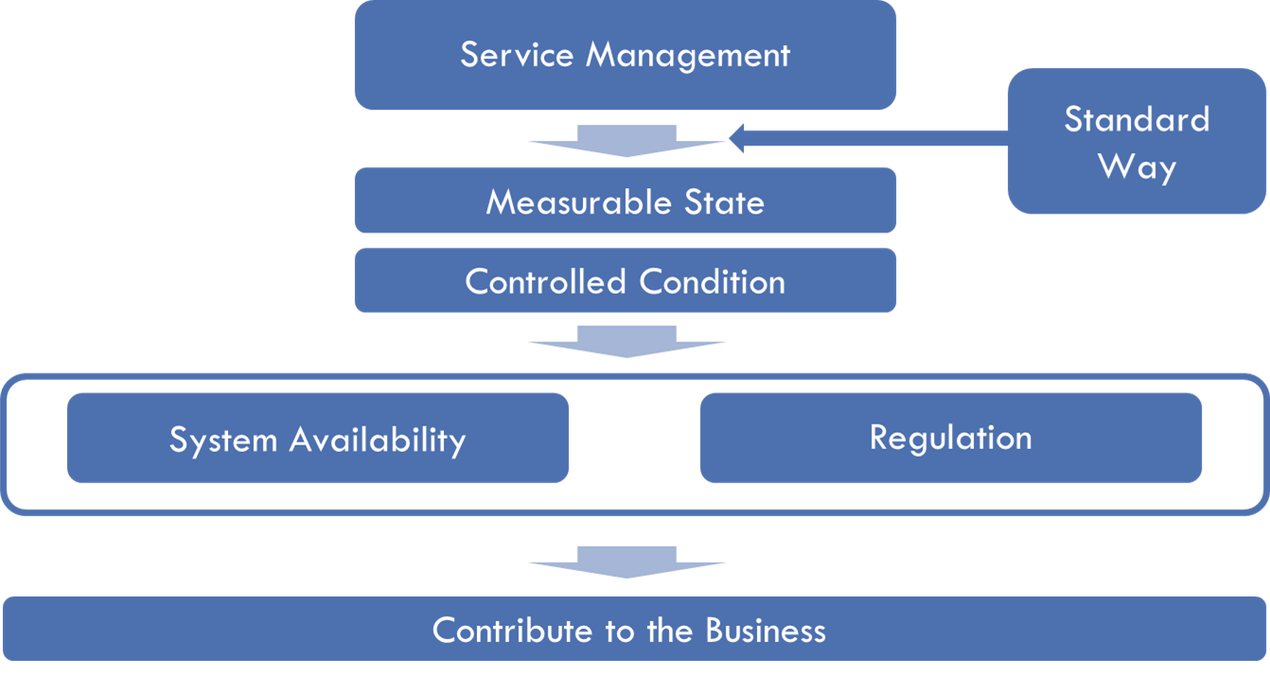

Roadmap

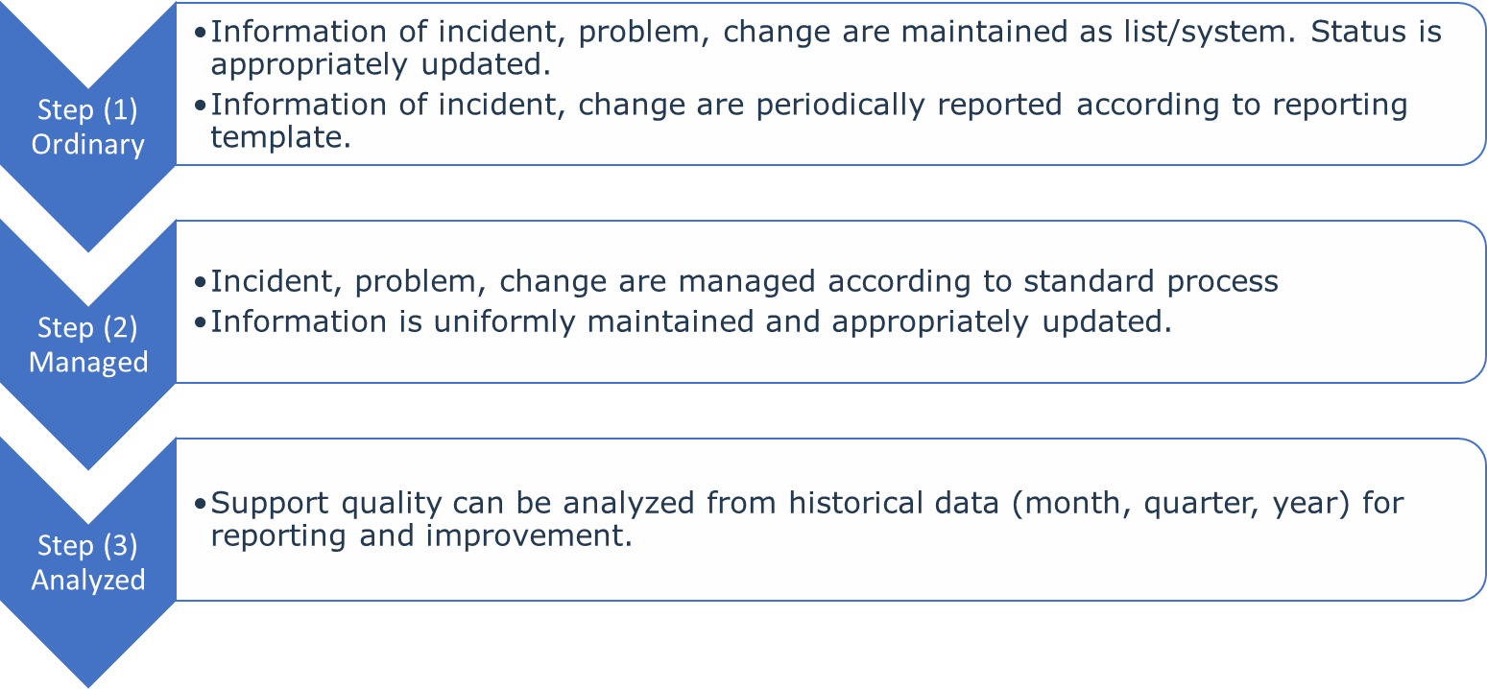

Issue Type and Support Process

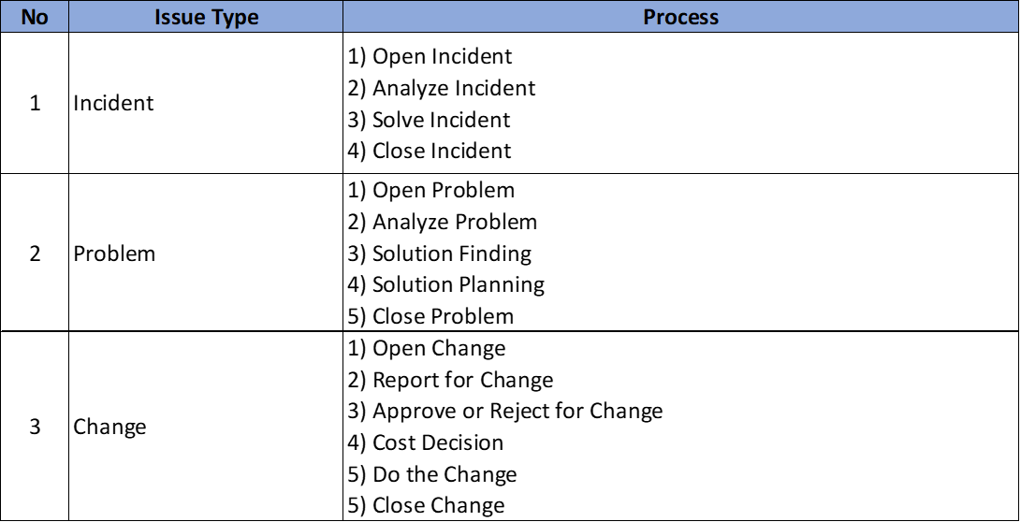

Standard Levels of Support

|  |  |  |  |
| --- | --- | --- | --- |
| **Stakeholder** | **ACE** | **Sunfix** | **SAP** |
| Support Level | Level 1 Support | Level 2 Support | Level 3 Support |
| Purpose | 1) Uuser Satisfaction 2)windows of users | 1) incident Solving 2) Problem Perventing 3) Change Operation | 1) incident Solving 2) Problem Perventing 3) Change Operation |
| Operation | 1) Receive Cell 2) Open Ticker 3) Answer 4) Escalation 5) Close Tickre | 1) Open Incident 2) Analyze Incident 3) Solve Incident 4) Escalation 5) Close Ticker | 1) Open Incident 2) Analyze Incident 3) Solve Incident 4) Close Ticker |
| Service Time | 9am -6am Monday- Friday (Myanmar Calender) Urgent Cases - Assist the Client immediately to resolve it regardless working hour or holiday | 8am -6am Monday- Friday (Myanmar Calender) Urgent Cases - Assist the Client immediately to resolve it regardless working hour or holiday | According the SAP Annual Technical Support |

Target Response Time and Resolution Time for Incidents

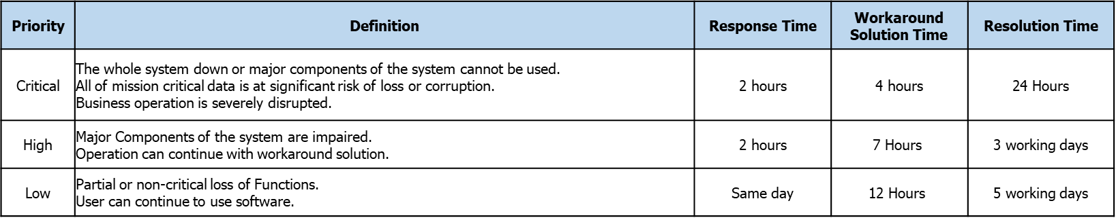

General Service Scope

1. Master Data Management which does not need configuration

2. For Period End Times, the Supplier will dispatch Support Engineer(s) on-site as necessary

3. Mini Assignment Project for small customization, custom report development, ad-hoc training (10 Man/Days)

4. Estimate 100 Man/Days Support per year. The remain Man/Days can be carried forward to the next year and can be utilized for small customization, custom report development, ad-hoc training

Incident Management System

The Supplier shall provide the Customer an Incident Management System where all Issues and Incidents are registered and logged.

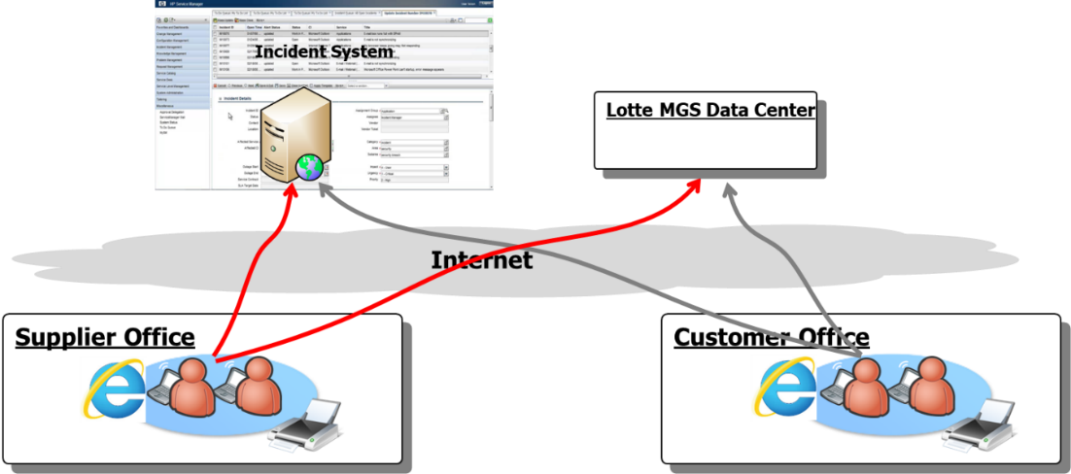

Heineken

In case, the Customer decides to establish its own Incident Management System, the Supplier shall utilize that Incident Management System.

Templates, Forms and Registers such as Issue Log, Issue Summary, Change Log, Change Request Form shall be agreed by both Parties.

Fees

|  |  |  |
| --- | --- | --- |
| NO | DESCRIPTION | ANNUAL AMOUNT |
| 1 | 1st Year Application Maintenance Service (offsite) 10% of total implementation  Note: the support is based on operational support and cover as below:  -Mini assignment to existing company code (less than 10-man days)  -Design customs' reports  -Provide Ad Hoc Training | **$ 33,225.00** |

The Fees are exclusive of any local, state and international Taxes.